Settings things up

Entity modeling: we set up a simplified model, having one site, one area, one workstation, and two units. Physically we have one robotic cell performing part welding and polishing. We represented this in the figure below.
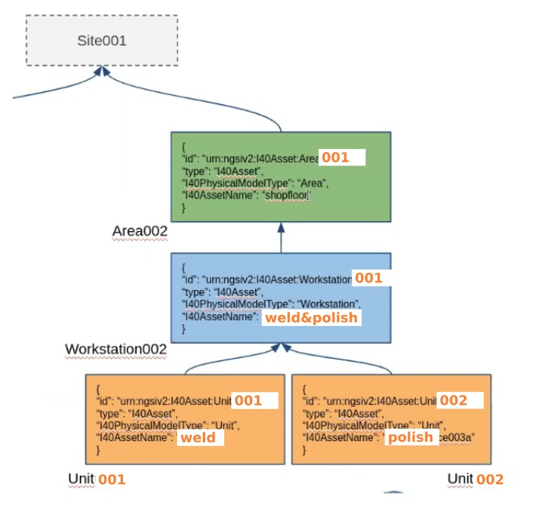

Note: all commands below use the curl software tool, and assume the Orion Context Broker is up and running, and available in the same (local) network.

To create the site:
curl -iX POST 'http://{context-broker-IP}:1026/v2/entities/' \
-H 'Content-Type: application/json' \
-d '{

"id": "urn:ngsiv2:i40Asset:Site:001", "type": "i40Asset", "i40AssetType": {"type": "string", "value": "Site"}

}
'
To create the area:
curl -iX POST 'http://{context-broker-IP}:1026/v2/entities/' \
-H 'Content-Type: application/json' \
-d '{

"id": "urn:ngsiv2:i40Asset:Area:001", "type": "i40Asset", "i40AssetType": {"type": "string", "value": "Area"}, "hasParentI40Asset": {"type": "string", "value": "urn:ngsiv2:i40Asset:Site:001"}

}
'
To create the workstation:
curl -iX POST 'http://{context-broker-IP}:1026/v2/entities/' \
-H 'Content-Type: application/json' \
-d '{

"id": "urn:ngsiv2:i40Asset:Workstation:001", "type": "i40Asset", "i40AssetType": {"type": "string", "value": "Workstation"}, "hasParentI40Asset": {"type": "string", "value": "urn:ngsiv2:i40Asset:Area:001"}

}
'

To create workstation attributes (here its state):

curl -iX POST 'http://{context-broker-IP}:1026/v2/entities/urn:ngsiv2:i40Asset:Workstation:001/attrs' \
-H 'Content-Type: application/json' \
-d '{

"i40AssetState": {"type": "string", "value": "STOPPED"}
}
'

To create the two units:
curl -iX POST 'http://{context-broker-IP}:1026/v2/entities/' \
-H 'Content-Type: application/json' \
-d '{

"id": "urn:ngsiv2:i40Asset:Unit:001a", "type": "i40Asset", "i40AssetType": {"type": "string", "value": "Unit"}, "hasParentI40Asset": {"type": "string", "value": "urn:ngsiv2:i40Asset:Workstation:001"}

}
'
and
curl -iX POST 'http://{context-broker-IP}:1026/v2/entities/' \
-H 'Content-Type: application/json' \
-d '{

"id": "urn:ngsiv2:i40Asset:Unit:002a", "type": "i40Asset", "i40AssetType": {"type": "string", "value": "Unit"}, "hasParentI40Asset": {"type": "string", "value": "urn:ngsiv2:i40Asset:Workstation:001"}

}
'

The outcome, as seen on the context broker machine:
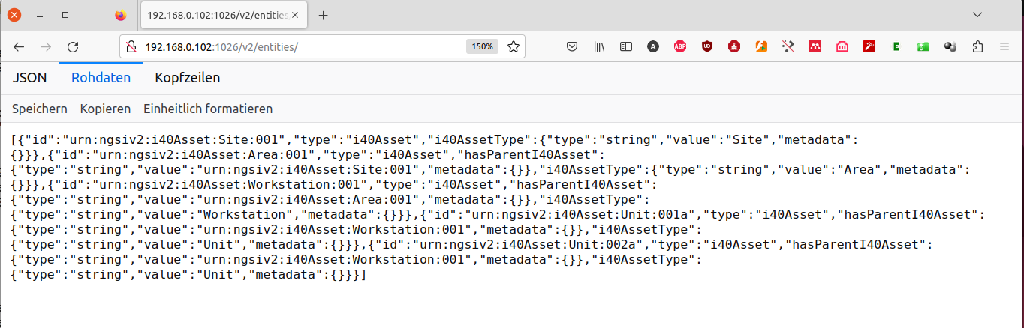

To manage workstation states, we used this command template:
curl -iX PUT 'http://{context-broker-IP}:1026/v2/entities/urn:ngsiv2:i40Asset:Workstation:001/attrs/i40AssetState/value' \
-H 'Content-Type: application/json' \
-d '{

"value": "STARTING"

}
'
where {state} could be IDLE, STARTING, RUNNING, STANDBY, STOPPING, or ERROR.

Persisting Time Series data

In our current setup, we used Quantumleap directly to persist TimeSeries data. To do this, our broker creates a subscription for the workstation to Quantumleap and then posts data directly. To create the subscription, we used this command:

(here the CRATE view in browser: http://localhost:4200)
(here the subscriptions: http://localhost:1026/v2/subscriptions – access this to get the subscription IDs which you need below!!)

curl -iX POST \
--url 'http://{context-broker-IP}:1026/v2/subscriptions' \
--header 'content-type: application/json' \
--data '{
"description": "WorkstationSubscription",
"subject": {
"entities": [
{
"idPattern": ".*",
"type": "Workstation"
}
],
"condition": {
"attrs": [
"prt_cntr_good", "prt_cntr_bad", "ws_state", "mode_tme_auto", "mode_tme_man", "mode_tme_init", "mode_tme_chg", "mode_tme_stop", "ws_msg"
]
}
},
"notification": {
"http": {
"url": "http://{context-broker-IP}:8668/v2/notify"
},
"attrs": [
"prt_cntr_good", "prt_cntr_bad", "ws_state", "mode_tme_auto", "mode_tme_man", "mode_tme_init", "mode_tme_chg", "mode_tme_stop", "ws_msg"
],
"metadata": ["dateCreated", "dateModified"]
}
}
'

The parameter meanings are as follows:
- "prt_cntr_good": counter for good parts; if a part processing operations has a correct outcome, it will held value 1
- "prt_cntr_bad": similar meaning, but for an outcome with a „non-compliant“ part
- "ws_state": the new workstation state (we may discontinue to use this param)
- "mode_tme_auto", "mode_tme_man", "mode_tme_init", "mode_tme_chg", "mode_tme_stop": time of the just completed operation, as follows: _auto, for producing a part in „auto“ mode, _man for performing in manual mode, _init for initialization time (from OFF to STANDBY), _chg for changing the program parameters, and _stop for stopping (going from STANDBY or IDLE to OFF)
- "ws_msg": a supplementary text message to clarify the outcome of the completed operation

To exemplify, the broker uses then this command to insert into Quantumleap the information that the workstation is starting (from OFF it goes to STANDBY):

curl http://{context-broker-IP}:8668/v2/notify -s -S -H 'Content-Type: application/json' -d @- <<EOF
{
"subscriptionId": "{workstation-subscription-id}",
"data": [
{
"id": "Workstation1",
"prt_cntr_good":
{
"value": "0",
"type": "Number"
},
"prt_cntr_bad":
{
"value": "0",
"type": "Number"
},
"ws_state":
{
"value": "STANDBY",
"type": "Text"
},
"mode_tme_auto":
{
"value": "0",
"type": "Number"
},
"mode_tme_man":
{
"value": "0",
"type": "Number"
},
"mode_tme_init":
{
"value": "24",
"type": "Number"
},
"mode_tme_chg":
{
"value": "0",
"type": "Number"
},
"mode_tme_stop":
{
"value": "0",
"type": "Number"
},

"ws_msg":
{
"value": "Workstation initialized ok, status: STANDBY",
"type": "Text"
},
"type": "Workstation"
}
]
}
EOF

Here an example of what is persisted when an operation on a part is started:
curl http://{context-broker-IP}:8668/v2/notify -s -S -H 'Content-Type: application/json' -d @- <<EOF
{
"subscriptionId": "{workstation-subscription-id}",
"data": [
{
"id": "Workstation1",
"prt_cntr_good":
{
"value": "0",
"type": "Number"
},
"prt_cntr_bad":
{
"value": "0",
"type": "Number"
},
"ws_state":
{
"value": "RUNNING",
"type": "Text"
},
"mode_tme_auto":
{
"value": "0",
"type": "Number"
},
"mode_tme_man":
{
"value": "0",
"type": "Number"
},
"mode_tme_init":
{
"value": "0",
"type": "Number"
},
"mode_tme_chg":
{
"value": "0",
"type": "Number"
},
"mode_tme_stop":
{
"value": "0",
"type": "Number"
},

"ws_msg":
{
"value": "Processing command – working on part; new state: RUNNING",
"type": "Text"
},
"type": "Workstation"
}
]
}
EOF

Here an example of what is persisted when an operation on a part is finished (part is produced):
curl http://{context-broker-IP}:8668/v2/notify -s -S -H 'Content-Type: application/json' -d @- <<EOF
{
"subscriptionId": "{workstation-subscription-id}",
"data": [
{
"id": "Workstation1",
"prt_cntr_good":
{
"value": "1",
"type": "Number"
},
"prt_cntr_bad":
{
"value": "0",
"type": "Number"
},
"ws_state":
{
"value": "STANDBY",
"type": "Text"
},
"mode_tme_auto":
{
"value": "232",
"type": "Number"
},
"mode_tme_man":
{
"value": "0",
"type": "Number"
},
"mode_tme_init":
{
"value": "0",
"type": "Number"
},
"mode_tme_chg":
{
"value": "0",
"type": "Number"
},
"mode_tme_stop":
{
"value": "0",
"type": "Number"
},
"ws_msg":
{
"value": "Part produced ok",
"type": "Text"
},
"type": "Workstation"
}
]
}
EOF

Our broker creates also a „unit“ subscription to Quantumleap and then posts time series data related to parts (actually the operation performed on the part). To create the unit subscription, we used this command:

curl -iX POST \
--url 'http://{context-broker-IP}:1026/v2/subscriptions' \
--header 'content-type: application/json' \
--data '{
"description": "UnitSubscription",
"subject": {
"entities": [
{
"idPattern": ".*",
"type": "Unit"
}
],
"condition": {
"attrs": [
"part_id", "ref_id", "prt_status", "prt_cyc_tme", "weld_len", "weld_tme", "plsh_len", "plsh_tme", "prt_msg"
]
}
},
"notification": {
"http": {
"url": "http://{context-broker-IP}:8668/v2/notify"
},
"attrs": [
"part_id", "ref_id", "prt_status", "prt_cyc_tme", "weld_len", "weld_tme", "plsh_len", "plsh_tme", "prt_msg"
],
"metadata": ["dateCreated", "dateModified"]
}
}
'

The attribute meaning is as follows:
- "part_id": the part identifier
- "ref_id": an internal reference id
- "prt_status": if the part is compliant or not
- "prt_cyc_tme": operation time
- "weld_len": length (mm) of welding
- "weld_tme": time (s) needed for the welding
- "plsh_len": length (mm) of polishing
- „plsh_tme" : time (s) needed for the polishing
- "prt_msg": a customizable string message

Here is an example of persisting information on the outcome of processing part with id P2290001:
curl http://{context-broker-IP}:8668/v2/notify -s -S -H 'Content-Type: application/json' -d @- <<EOF
{
"subscriptionId": "{unit-subscription-id}",
"data": [
{
"id": "Unit1",
"part_id":
{
"value": "P2290001",
"type": "Text"
},
"ref_id":
{
"value": "R20001",
"type": "Text"
},
"prt_status":
{
"value": "GOOD",
"type": "Text"
},
"prt_cyc_tme":
{
"value": "232",
"type": "Number"
},
"weld_len":
{
"value": "820",
"type": "Number"
},
"weld_tme":
{
"value": "132",
"type": "Number"
},
"plsh_len":
{
"value": "820",
"type": "Number"
},
"plsh_tme":
{
"value": "100",
"type": "Number"
},
"prt_msg":
{
"value": "Part produced ok",
"type": "Text"
},
"type": "Unit"
}
]
}
EOF

Here is another example of processing part with id P2290002:
curl http://{context-broker-IP}:8668/v2/notify -s -S -H 'Content-Type: application/json' -d @- <<EOF
{
"subscriptionId": "{unit-subscription-id}",
"data": [
{
"id": "Unit1",
"part_id":
{
"value": "P2290002",
"type": "Text"
},
"ref_id":
{
"value": "R20001",
"type": "Text"
},
"prt_status":
{
"value": "BAD",
"type": "Text"
},
"prt_cyc_tme":
{
"value": "232",
"type": "Number"
},
"weld_len":
{
"value": "820",
"type": "Number"
},
"weld_tme":
{
"value": "132",
"type": "Number"
},
"plsh_len":
{
"value": "820",
"type": "Number"
},
"plsh_tme":
{
"value": "100",
"type": "Number"
},
"prt_msg":
{
"value": "FAILURE!! producing part",
"type": "Text"
},
"type": "Unit"
}
]
}
EOF

Configuration cleanup commands used while testing
To clean up, while testing, we used this command template:
curl -iX DELETE 'http://{context-vm-ip}:1026/v2/entities/{asset-id}/'

curl -iX DELETE \
--url 'http://{context-vm-ip}:1026/v2/subscriptions/{subscription-id}'

